Project Report

Title:
Denial of Service (DoS) Attack and Mitigation in a Virtualized Environment

Abstract
This project demonstrates two common Denial of Service (DoS) attacks, namely SYN Flood and HTTP Flood, in a controlled virtual lab environment. The attacks were performed using Kali Linux as the attacker machine and Metasploitable as the victim machine. After successfully generating the attacks, mitigation techniques were applied and tested to reduce their impact. The purpose of this project is to understand how DoS attacks affect network services and how security controls can be implemented to defend against them.

Objectives
- Understand the concept of Denial of Service attacks.
- Perform SYN Flood and HTTP Flood attacks in a controlled lab.
- Analyze the impact of both attacks on the victim system.
- Implement mitigation techniques.
- Verify whether the applied mitigation successfully reduces the attack impact.

Lab Environment
Component | Description
Hypervisor | VirtualBox / VMware
Attacker Machine | Kali Linux
Victim Machine | Metasploitable
Network Type | Host-Only Adapter / NAT
Attack Types | SYN Flood, HTTP Flood

Introduction
A Denial of Service (DoS) attack is a cyberattack that attempts to make a system, server, or network unavailable to legitimate users. Attackers overwhelm the target with excessive requests, consuming resources and preventing normal operations.
In this project, two types of DoS attacks were demonstrated:
- SYN Flood Attack
- HTTP Flood Attack

Part 1: SYN Flood Attack

What is SYN Flood?
A SYN Flood attack abuses the TCP three-way handshake process by sending a large number of SYN packets without completing the connection. This causes the target server to maintain many half-open connections, consuming resources and potentially making the service unavailable.

Step 1: Verify Connectivity
Ensure Kali Linux can communicate with Metasploitable.
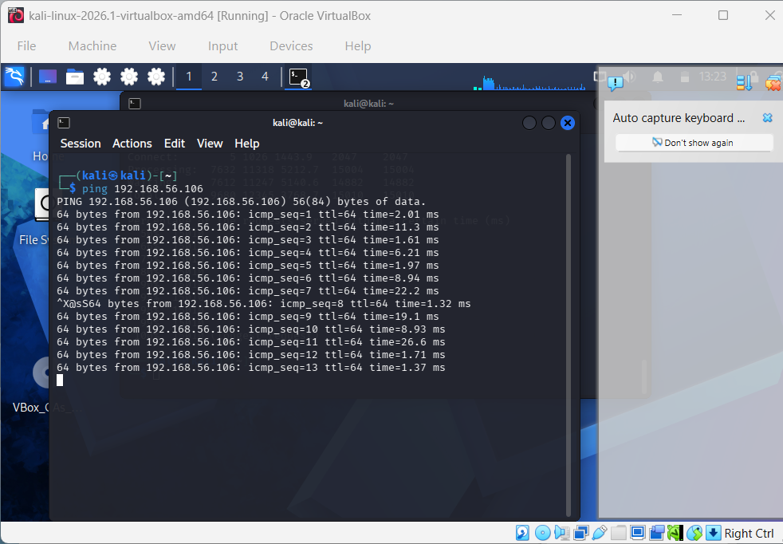
Explanation:
Before launching the attack, connectivity between attacker and victim machines was verified.

Step 2: Start SYN Flood Attack
Execute the SYN Flood attack from Kali Linux against the Metasploitable target.
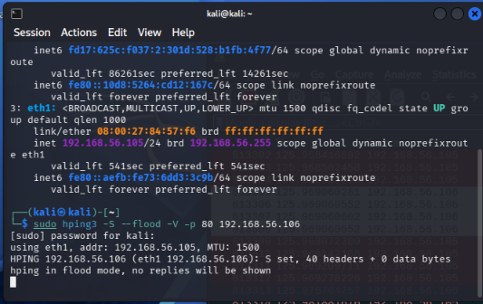
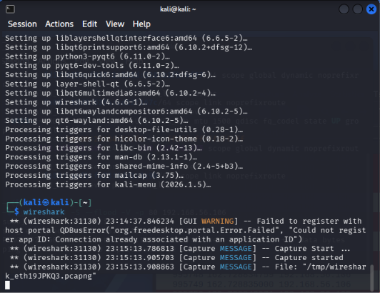
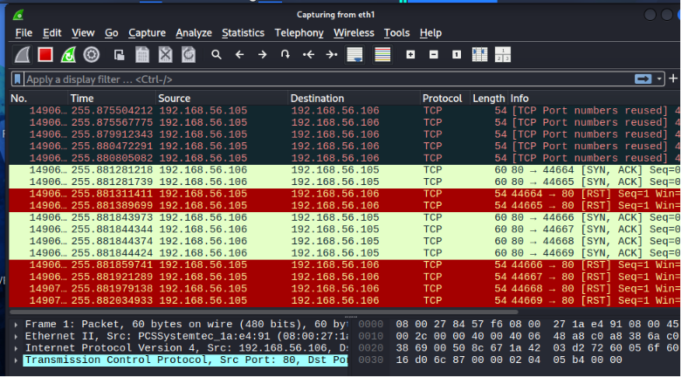

Explanation:
The attack tool continuously sends TCP SYN packets to the victim system.

Step 3: Monitor Victim System
Check active TCP connections on Metasploitable.
Command:
netstat -ant | grep SYN_RECV
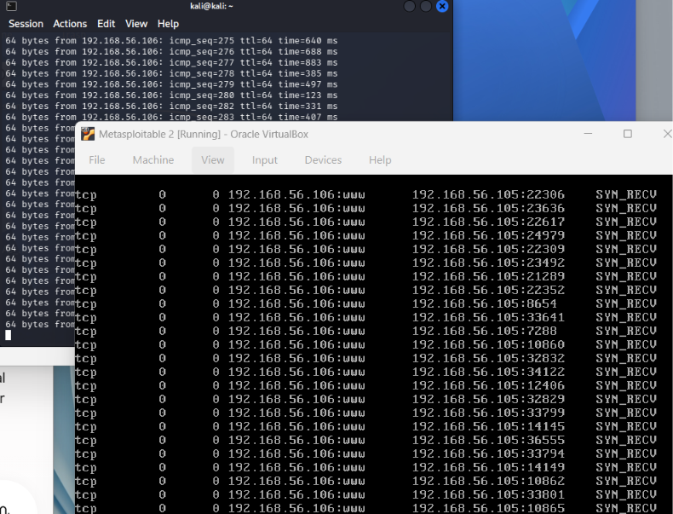
Explanation:
A large number of SYN_RECV entries indicate half-open connections created by the attack.

SYN Flood Mitigation

Step 4: Enable Protection Mechanism
Apply SYN Flood mitigation on the victim machine.
Possible mitigation techniques:
sysctl -w net.ipv4.tcp_syncookies=1
or firewall rules.
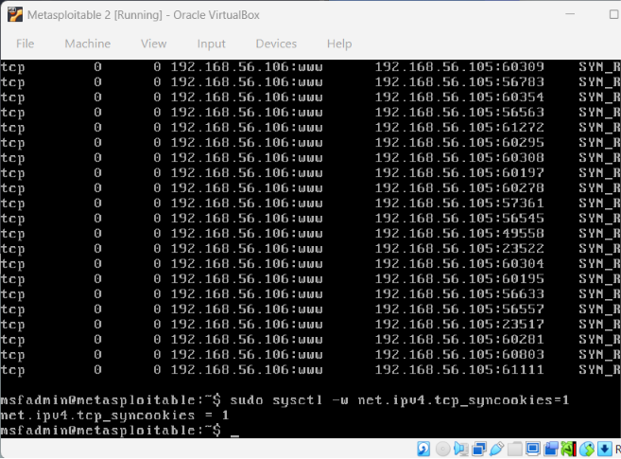

Explanation:
TCP SYN Cookies help the server resist SYN Flood attacks by preventing excessive resource allocation.

Step 5: Verify Mitigation
Monitor connections again.
Note: Due to an oversight during the experiment, the screenshot for mitigation verification was not captured. However, the effectiveness of the mitigation can be verified using the following command:
netstat -ant | grep SYN_RECV
This command displays the number of half-open TCP connections. After enabling TCP SYN Cookies, the number of SYN_RECV connections should decrease significantly, indicating successful mitigation of the SYN Flood attack.
Explanation:
The number of half-open connections decreases, demonstrating successful mitigation.

Part 2: HTTP Flood Attack

What is HTTP Flood?
An HTTP Flood attack overwhelms a web server by sending a large number of HTTP requests. Unlike SYN Flood attacks, HTTP Flood attacks target the application layer and consume web server resources.

Step 1: Verify Web Service Availability
Ensure the target web service is running.
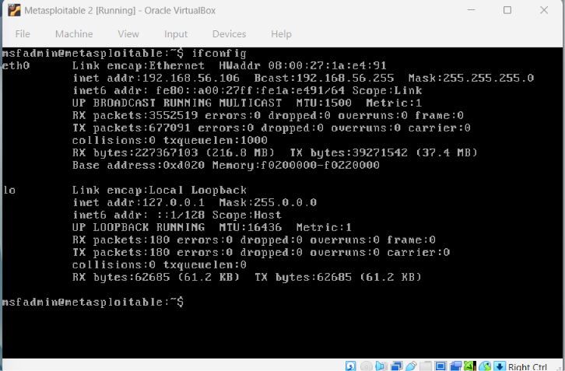
Explanation:
The victim web application was confirmed to be accessible before launching the attack.

Step 2: Launch HTTP Flood Attack
Run the HTTP Flood attack from Kali Linux.
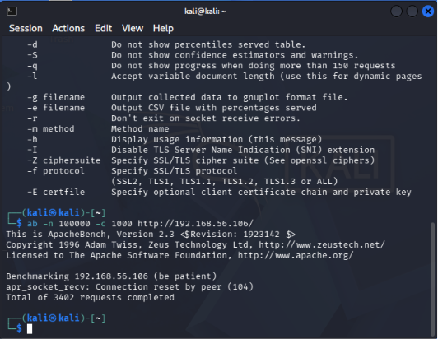
Explanation:
A large number of HTTP requests were generated to overload the victim web server.

Step 3: Observe Resource Consumption
Monitor the victim server during the attack.
top
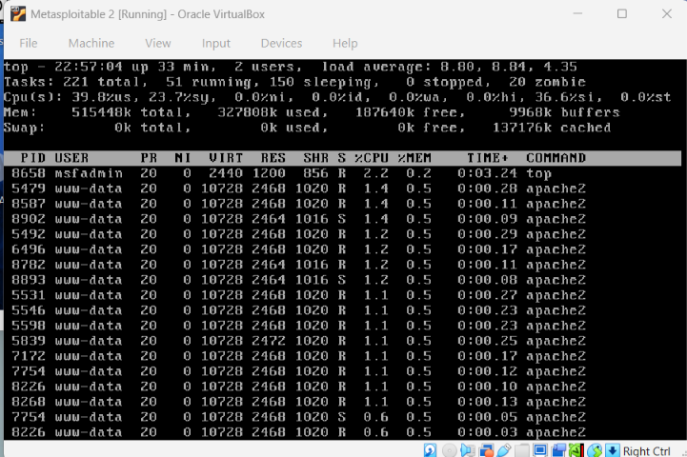
Explanation:
The server experiences increased resource utilization due to excessive requests.

HTTP Flood Mitigation

Step 4: Apply Rate Limiting / Firewall Rules
Implement HTTP request filtering or rate limiting.
Examples:
iptables
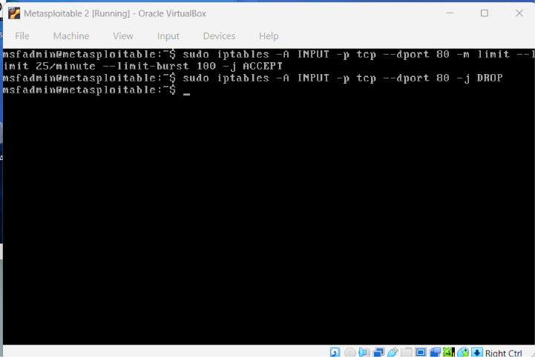
Explanation:
Rate limiting restricts the number of requests a client can make within a specified period.

Step 5: Verify Mitigation
Repeat monitoring after mitigation.
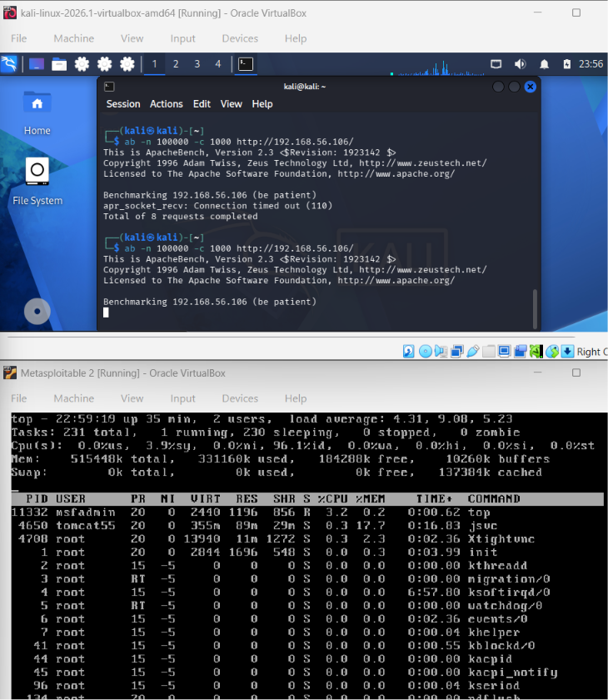
Explanation:
The server remains stable despite incoming requests, showing that mitigation is effective.

Results
Attack Type | Before Mitigation | After Mitigation
SYN Flood | High number of SYN_RECV connections | Reduced SYN_RECV connections
HTTP Flood | High server load and request volume | Controlled traffic and improved stability

Conclusion
This project successfully demonstrated SYN Flood and HTTP Flood attacks within a virtualized environment using Kali Linux and Metasploitable. The attacks highlighted how system resources can be exhausted through malicious traffic. Appropriate mitigation techniques such as SYN Cookies, firewall filtering, and rate limiting significantly reduced the impact of the attacks. The project provided practical experience in both offensive and defensive aspects of Information Security.

